Photos taken at Cataloochee Ranch, Maggie Valley, NC
8/14/08
Chestnut seedlings in second year of growth
91% survival of 281 planted as seed

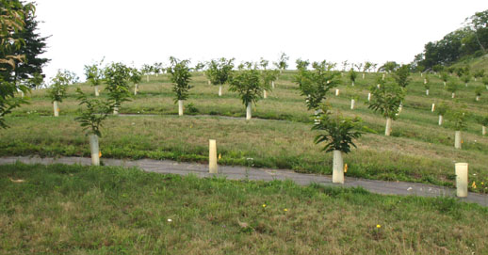
Overview of Cataloochee Ranch chestnut orchard in 2nd year of growth from seed

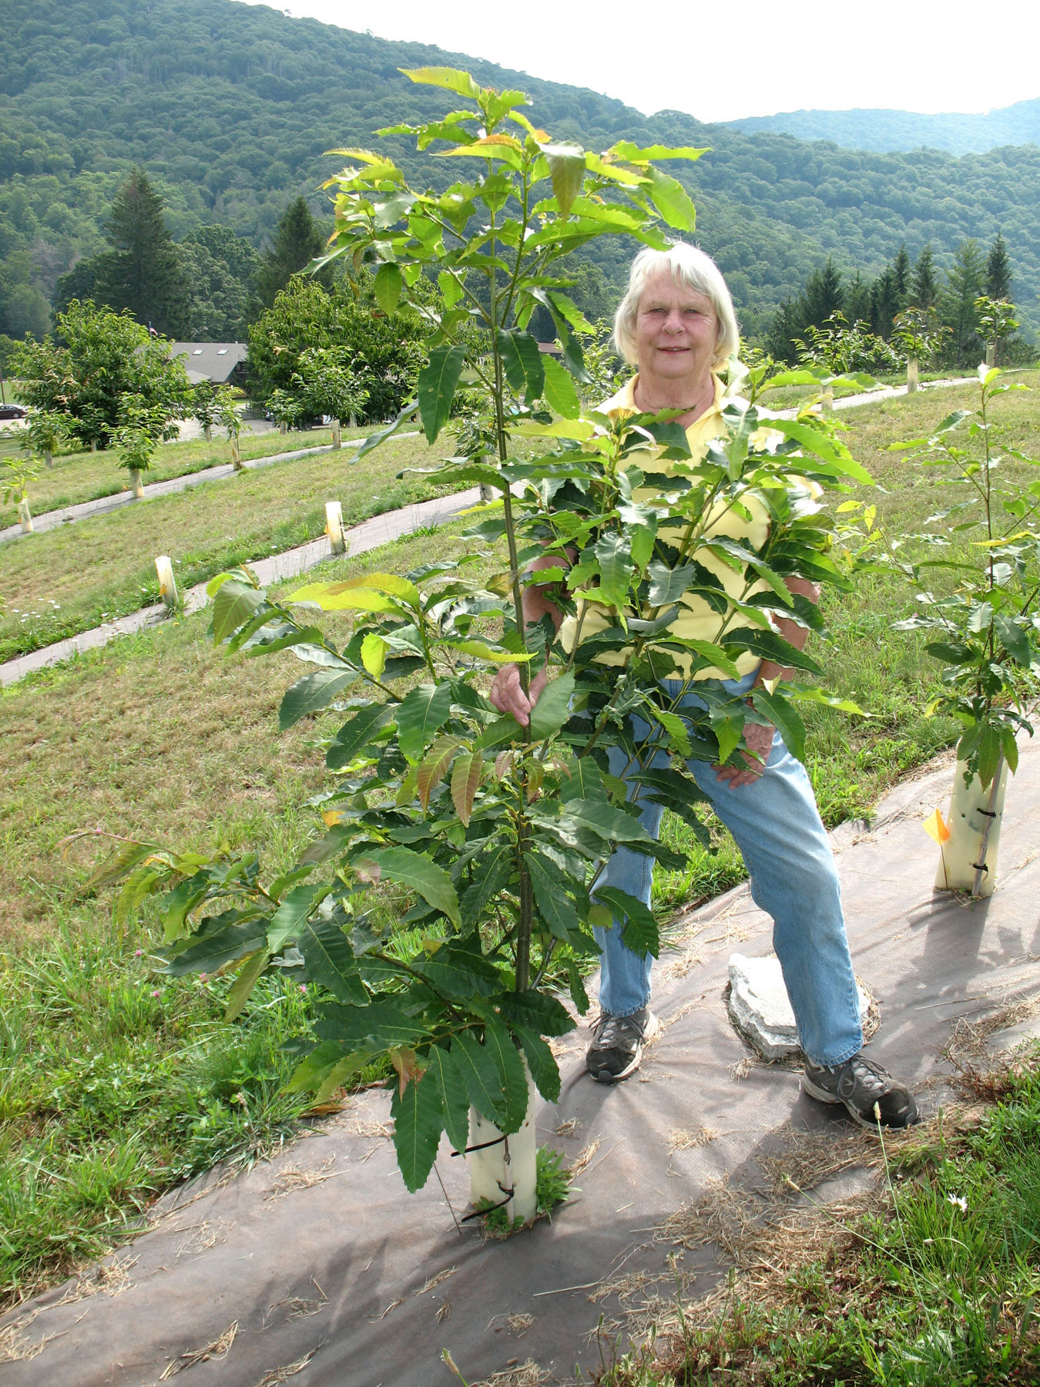
The winner. Seedling from cross of Ted
Farmer Amer (Avery Co, NC) x IL151

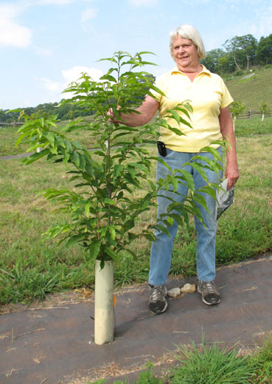
Elk Knob Amer x CB258

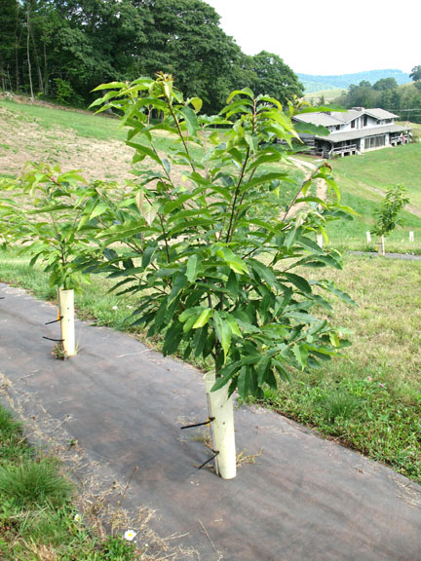
Bina Rd. Amer x CH283

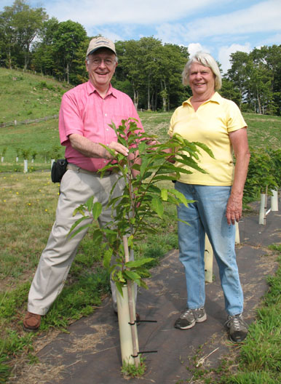
An F1 control: Ted Farmer Amer x Morrow Mountain Japanese Chestnut

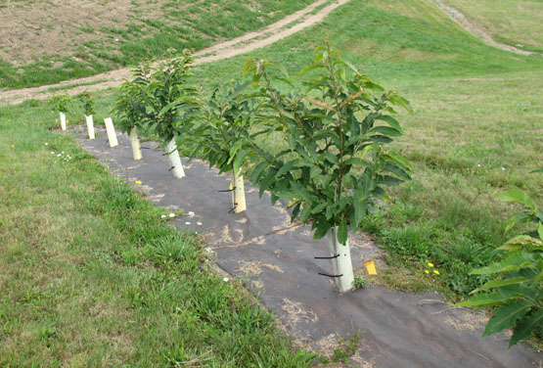
American chestnut from seed collected around Montreat NC by Bryan Joyce and Luke Snyder

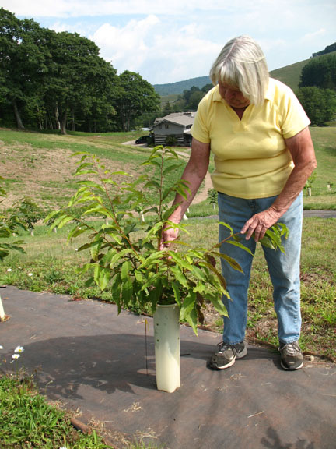
American chestnut from seed collected by Joe Schibig on Yellow Mountain near Highlands, NC

